UNIT - V
Introduction
Array
- An array is an indexed collection of fixed no of homogeneous data elements. (or) An array represents a group of elements of same data type.
- The main advantage of array is we can represent huge no of elements by using single variable. So that readability of the code will be improved.
Limitations of array:
- Arrays are fixed in size that is once we created an array there is no chance of increasing (or) decreasing the size based on our requirement
- Arrays can hold only homogeneous data elements.
- Arrays concept is not implemented based on some data structure hence ready-made methods support we can't expect. For every requirement we have to write the code explicitly
To overcome the above limitations we should go for collections concept
- Collections are growable in nature that is based on our requirement we can increase (or) decrease the size hence memory point of view collections concept is recommended to use.
- Collections can hold both homogeneous and heterogeneous objects.
- Every collection class is implemented based on some standard data structure hence for every requirement ready-made method support is available

Sr.no | Array | Collection Framework
1 | Fixed-size (not growable) | Growable in nature
2 | If the size is 10 and only 5 elements store then it is a waste of memory. | It adjusts size according to elements.
3 | Arrays can hold only homogeneous data elements. | Collection can hold homogeneous as well as heterogeneous data elements.
4 | Memory management is poor. | Memory management is effective.

Collections overview
The Java Collections Framework standardizes the way in which groups of objects are handled by your programs.
What is Collection in Java
A Collection represents a single unit of objects, i.e., a group.
What is a framework in Java
A framework is a set of classes and interfaces which provide a ready-made architecture.
- It provides readymade architecture.
- It represents a set of classes and interfaces.
What is Collection framework
The Collection framework represents a unified architecture for storing and manipulating a group of objects. It has:
- Interfaces and its implementations, i.e., classes
- Algorithm
Hierarchy of Collection Framework
The java.util package contains all the classes and interfaces for the Collection framework.

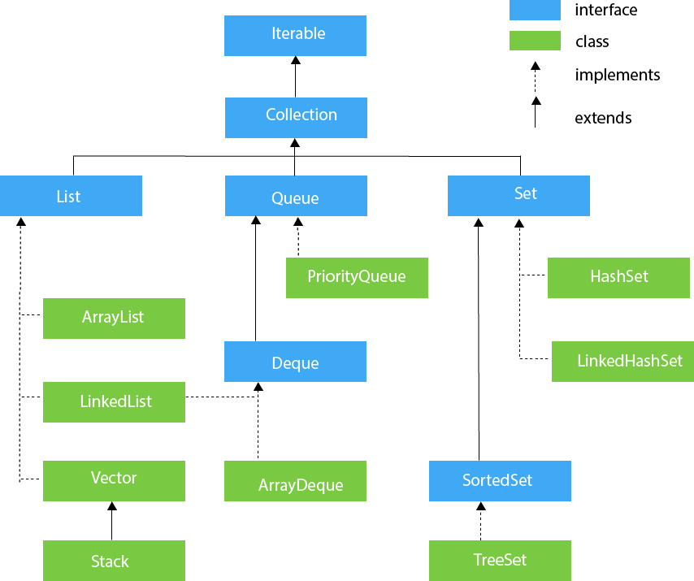
The Collections Framework was designed to meet several goals.
- The framework is designed to have high-performance.
- The framework allows different types of collections to work in a similar manner and with a high degree of interoperability.
- Extending and/or adapting a collection is easy.
- The entire Collections Framework is built upon a set of standard interfaces
Algorithms are another important part of the collection mechanism. Algorithms operate on collections and are defined as static methods within the Collections class
An Iterator interface is associated with Collections Framework. An iterator offers a general-purpose, standardized way of accessing the elements within a collection, one at a time. Thus, an iterator provides a means of enumerating the contents of a collection. Because each collection implements Iterator, the elements of any collection class can be accessed through the methods defined by Iterator.
Autoboxing/unboxing facilitates the storing of primitive types in collections. Java can automatically perform the proper boxing and unboxing needed when storing or retrieving primitive types. There is no need to manually perform these operations.
A collection can be cycled through by use of the for-each style for loop

Iterable interface
Iterable interface is the root interface for the entire collection framework. The collection interface extends the iterable interface. The main functionality of this interface is to provide an iterator for the collections.
The Collection Interfaces
- The Collections Framework defines several interfaces.
- The Collection interface is the root interface of the collections framework hierarchy.
- Java does not provide direct implementations of the Collection interface but provides implementations of its sub-interfaces like List, Set, and Queue.
- It provides basic operations like adding, removing, clearing the elements in a collection, checking whether the collection is empty, etc.
- Syntax
interface Collection <E>
E specifies the type of objects that the collection will hold

Methods of Collection interface

Method | Description
public boolean add(E e) | It is used to insert an element in this collection.
public boolean addAll(Collection< extends E> c) | It is used to insert the specified collection elements in the invoking collection.
public boolean remove(Object element) | It is used to delete an element from the collection.
Public boolean removeAll(Collection<?> c) | It is used to delete all the elements of the specified collection from the invoking collection.
default boolean removeIf(Predicate<? super E> filter) | It is used to delete all the elements of the collection that satisfy the specified predicate.
public boolean retainAll(Collection<?> c) | It is used to delete all the elements of invoking collection except the specified collection.
public int size() | It returns the total number of elements in the collection.
public void clear() | It removes the total number of elements from the collection.
public boolean contains(Object element) | It is used to search an element.
public boolean containsAll(Collection<?> c) | It is used to search the specified collection in the collection.
public Iterator iterator() | It returns an iterator.
public Object[] toArray() | It converts collection into array.
public boolean isEmpty() | It checks if collection is empty.
public boolean equals(Object element) | It matches two collections.
public int hashCode() | It returns the hash code number of the collection.

List Interface
- The list interface extends the collection interface.
- A list is used to store ordered collection of data and it may contain duplicates.
- Ordered collection means the order in which the elements are being inserted and they contain a specific value.
- The elements present, can be accessed or inserted by their position in the list using zero-based indexing.
- The list interface is implemented by LinkedList, ArrayList, Vectors and Stack classes.
- They are an important part of collections in Java.

Method | Description
void add(int index, E element) | It is used to insert the specified element at the specified position in a list.
boolean add(E e) | It is used to append the specified element at the end of a list.
boolean addAll(Collection<? extends E> c) | It is used to append all of the elements in the specified collection to the end of a list.
boolean addAll(int index, Collection<? extends E> c) | It is used to append all the elements in the specified collection, starting at the specified position of the list.
void clear() | It is used to remove all of the elements from this list.
boolean equals(Object o) | It is used to compare the specified object with the elements of a list.
int hashcode() | It is used to return the hash code value for a list.
E get(int index) | It is used to fetch the element from the particular position of the list.
boolean isEmpty() | It returns true if the list is empty, otherwise false.
int lastIndexOf(Object o) | It is used to return the index in this list of the last occurrence of the specified element, or -1 if the list does not contain this element.
Object[] toArray() | It is used to return an array containing all of the elements in this list in the correct order.
boolean contains(Object o) | It returns true if the list contains the specified element
boolean containsAll(Collection<?> c) | It returns true if the list contains all the specified element
int indexOf(Object o) | It is used to return the index in this list of the first occurrence of the specified element, or -1 if the List does not contain this element.
E remove(int index) | It is used to remove the element present at the specified position in the list.
boolean remove(Object o) | It is used to remove the first occurrence of the specified element.
boolean removeAll(Collection<?> c) | It is used to remove all the elements from the list.
void replaceAll(UnaryOperator<E> operator) | It is used to replace all the elements from the list with the specified element.
void sort(Comparator<? super E> c) | It is used to sort the elements of the list on the basis of specified comparator.
List<E> subList(int fromIndex, int toIndex) | It is used to fetch all the elements lies within the given range.
int size() | It is used to return the number of elements present in the list.

Set interface
- The Set interface defines an unordered collection.
- It extends the Collection Interface.
- We cannot store duplicate values in this.
- The Set Interface is implemented by popular classes like HashedSet, LinkedHashSet, and TreeSet.

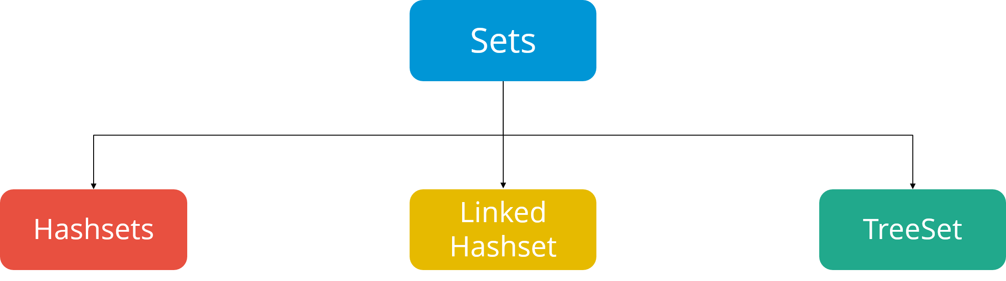
Methods of Set
The Set interface includes all the methods of the Collection interface. It's because Collection is a super interface of Set.
Some of the commonly used methods of the Collection interface that's also available in the Set interface are:
- add() - adds the specified element to the set
- addAll() - adds all the elements of the specified collection to the set
- iterator() - returns an iterator that can be used to access elements of the set sequentially
- remove() - removes the specified element from the set
- removeAll() - removes all the elements from the set that is present in another specified set
- retainAll() - retains all the elements in the set that are also present in another specified set
- clear() - removes all the elements from the set
- size() - returns the length (number of elements) of the set
- toArray() - returns an array containing all the elements of the set
- contains() - returns true if the set contains the specified element
- containsAll() - returns true if the set contains all the elements of the specified collection
- hashCode() - returns a hash code value (address of the element in the set)

Set Operations
The Java Set interface allows us to perform basic mathematical set operations like union, intersection, and subset.
- Union - to get the union of two sets x and y, we can use x.addAll(y)
- Intersection - to get the intersection of two sets x and y, we can use x.retainAll(y)
- Subset - to check if x is a subset of y, we can use y.containsAll(x)

Database Programming
Java offers a clean and simple approach for database connectivity through JDBC using which a java application can connect virtually to any database.
JDBC stands for Java Database Connectivity. JDBC is a Java API to connect and execute the query with the database.
JDBC manages connecting to a database, issuing queries and commands, and handling result sets obtained from the database.
It is used to write programs required to access databases. JDBC, along with the database driver, can access databases.
JDBC API support is made available to Java applications through 2 packages.

- java.sql
- javax.sql
java.sql package offers a set of fundamental interfaces and classes used for java-database communication. Extension package is used for advanced Java-database operations.
JDBC ARCHITECTURE
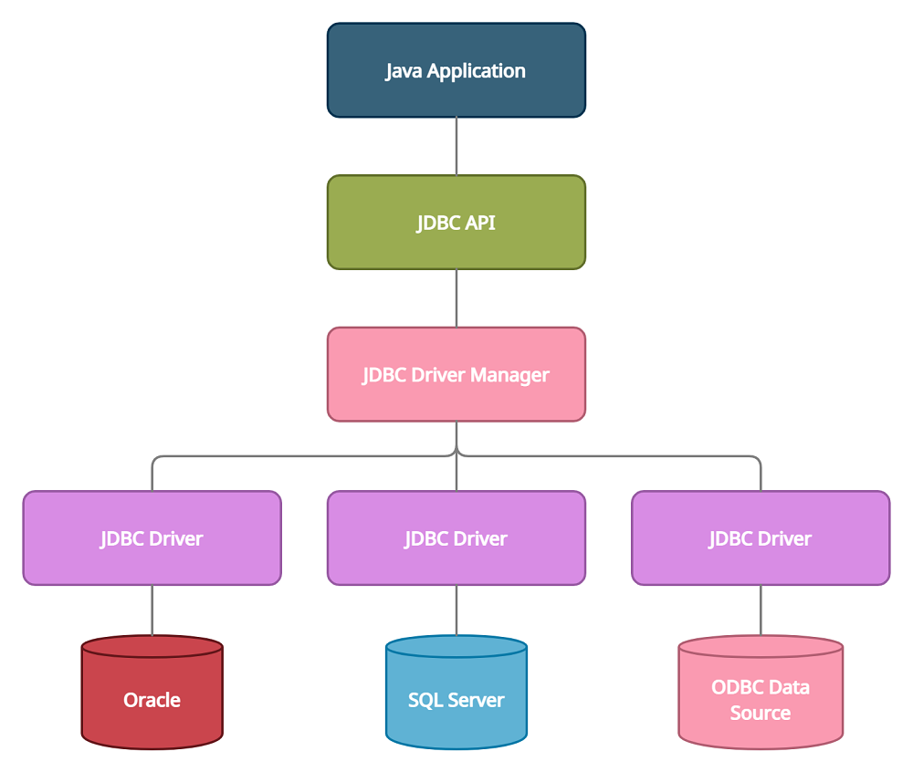

Java Application: – It can be a stand-alone java program, a servlet, a jsp, a Java bean, which uses the JDBC API to get connected and perform operations on the database data.
JDBC API: – It is a set of classes and interfaces used in a java program for database operations. java.sql & javax.sql packages provide the necessary library support.
DriverManager: – Java program uses DriverManager to get the connection with the database.
Driver: – It is the software that establishes connection with the database. It is the translation software that translates the JDBC method calls. This software enables the communication between java program and the database.
Database: – Enterprise data is stored in the database.

JDBC Driver

JDBC Driver is a software component that enables java application to interact with the database. JDBC drivers are client-side adapters (installed on the client machine, not on the server) that convert requests from Java programs to a protocol that the DBMS can understand.
There are 4 types of JDBC drivers:
Type-1 driver or JDBC-ODBC bridge driver
Type-2 driver or Native-API driver (partially java driver)
Type-3 driver or Network Protocol driver (fully java driver)
Type-4 driver or Thin driver (fully java driver)
Type 1: JDBC-ODBC Bridge Driver
- In a Type 1 driver, a JDBC bridge is used to access ODBC drivers installed on each client machine.
- Using ODBC, requires configuring on your system a Data Source Name (DSN) that represents the target database.
- When Java first came out, this was a useful driver because most databases only supported ODBC access but now this type of driver is recommended only for experimental use or when no other alternative is available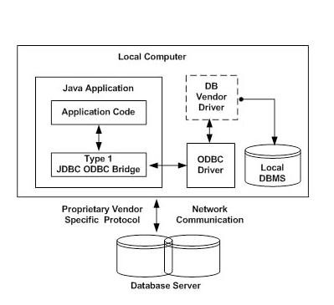
Type 2: JDBC-Native API
- In a Type 2 driver, JDBC API calls are converted into native C/C++ API calls, which are unique to the database.
- These drivers are typically provided by the database vendors and used in the same manner as the JDBC-ODBC Bridge.
- The vendor-specific driver must be installed on each client machine
- If we change the Database, we have to change the native API, as it is specific to a database.
- Type 2 driver eliminates ODBC's overhead.
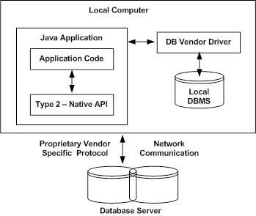
Type 3: JDBC-Net pure Java
- In a Type 3 driver, a three-tier approach is used to access databases.
- The JDBC clients use standard network sockets to communicate with a middleware application server.
- The socket information is then translated by the middleware application server into the call format required by the DBMS, and forwarded to the database server.
- This kind of driver is extremely flexible, since it requires no code installed on the client and a single driver can actually provide access to multiple databases.
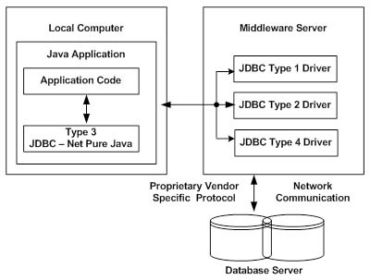
Type 4: 100% Pure Java
- In a Type 4 driver, a pure Java-based driver communicates directly with the vendor's database through socket connection.
- This is the highest performance driver available for the database and is usually provided by the vendor itself.
- This kind of driver is extremely flexible, you don't need to install special software on the client or server.
- These drivers can be downloaded dynamically.

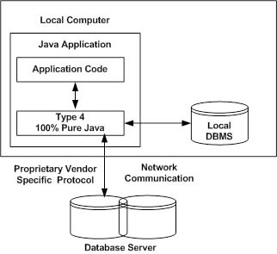
Which Driver should be used?
- If you are accessing one type of database at a time, such as Oracle, Sybase, or IBM, the preferred driver type is 4.
- If your Java application is accessing multiple types of databases at the same time, type 3 is the preferred driver.
- Type 2 drivers are useful in situations where a type 3 or type 4 driver is not available yet for your database.
- The type 1 driver is not considered a deployment- level driver and is typically used for development and testing purposes only.
Basic steps in developing JDBC applications
To connect to the database from java application we need to follow the below steps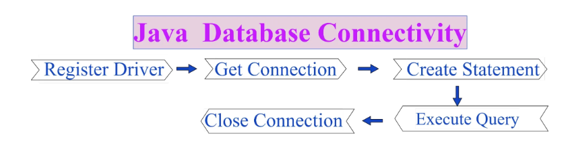

Import the packages:
This includes uploading all the packages containing the JDBC classes, interfaces, and subclasses used during the database programming.
import java.sql.* ;
Register the drivers:
Before connecting to the database, we’ll need to load or register the drivers once per database. This is done to create a communication channel with the database. These methods are used to load the JDBC driver into the application process space.
You can register the Driver by following two ways:
- Class.forName(“driver class name”) : Here we load the driver’s class file into memory at the runtime. No need of using new or creation of objects.
- DriverManager.registerDriver(): DriverManager is a Java inbuilt class with a static member register. Here we call the constructor of the driver class at compile time.
When the forName() method is successfully executed, three things happen in the background
- The driver class is loaded into memory.
- The driver class object is created.
- The driver class is registered with DriverManager.
Example
Class.forName("com.mysql.cj.jdbc.Driver");
Requesting for database connection
In order to establish a communication with the database, you must first open a JDBC connection to the database. After loading the driver, establish a connection. In java.sql.DriverManager class there is a static method “getConnection”. This method is used by the java program to request the database connection. Following are three methods of DriverManager.getConnection() :
getConnection(String url)
getConnection(String url, String user, String password)
Example:
Connection connection = DriverManager.getConnection("jdbc:mysql://localhost:3306/mydb", "root", "");
Creating Statement Object:
Once a connection is established you can interact with the database. The createStatement() method of the Connection interface is used to create a statement. The object of the statement is responsible to execute queries with the database.
Syntax
public Statement createStatement()throws SQLException
Example: Statement st = connection.createStatement();
The Statement object is designed to submit SQL statements from the JDBC client to the DBMS (via JDBC driver).

Submitting the SQL Statement:
Now its time to process the result by executing the query. The java.sql.Statement object has two important methods to submit SQL statements to the DBMS
- executeUpdate(String dml):– The executeUpdate(SQL query) method of Statement interface is used to execute queries of updating/inserting. This method is used to submit DML (INSERT, UPDATE, and DELETE) SQL statements.
- executeQuery (String drl):– The executeQuery() method of the Statement interface is used to execute queries to the database. This method returns the object of ResultSet that can be used to get all the records of a table. This method is used to submit the SELECT statement.
Retrieve results:
When queries are executed using the executeQuery() method, it produces results stored in the ResultSet object. The ResultSet object is then used to access the retrieved data from the database.
public abstract boolean next() throws java.sql.SQLException;
=> To check whether the next Record is available or not returns true if available otherwise returns false.
Example:
while (resultSet.next()) {
System.out.print(resultSet.getInt("rollno"));
System.out.println("\t"+ resultSet.getString("name"));
}

Close the Connection
So finally we have sent the data to the specified location. By closing the connection object statement and ResultSet will be closed automatically. The close() method of the Connection interface is used to close the connection.
Syntax : public void close()throws SQLException
Program
import java.sql.*;

public class Demo {

public static void main(String[] args) throws SQLException {

// Load the drivers using the forName() method.
try {
Class.forName("com.mysql.cj.jdbc.Driver");
} catch (Exception e) {
e.printStackTrace();
}

// Register the drivers using DriverManager.
// DriverManager.registerDriver(new com.mysql.cj.jdbc.Driver());

// Establish a connection using the Connection class object.
Connection connection = DriverManager.getConnection("jdbc:mysql://localhost:3306/mydb", "root", "");

// Create a statement.
Statement statement = connection.createStatement();

// Execute the query.
ResultSet resultSet = statement.executeQuery("SELECT * FROM student");

// Process the results.
while (resultSet.next()) {
System.out.print(resultSet.getInt("rollno"));
System.out.println("\t"+ resultSet.getString("name"));
}

// Close the connection.
connection.close();
}
}

JDBC classes and interfaces
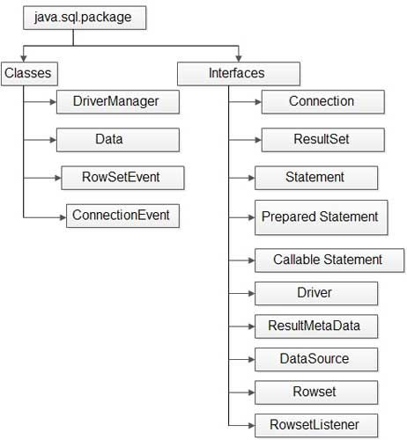
Some of major classes and interfaces which are frequently used while developing a Java application are as follows:

- DriverManager class
- Driver interface
- Connection interface
- Statement interface
- ResultSet interface

DriverManagerClass
It is a predefined class present/declared in java.sql package. It is a non-abstract class in the JDBC API. It has no constructor which implies that this class cannot be inherited or initialized directly.
All the methods or properties of this class are declared as static, so it is not necessary to construct an object of DriverManager Class.
The main responsibility of the DriverManager class is preparing a connection by using Driver implementation that accepts the given JDBC URL.

Methods in DriverManager
(a) public static Connection getConnection (String url, String user name, String pswd):
Establishes connection between driver and database. This class selects a driver from the list of drivers and creates a connection by checking user parameter for which the connection is being made.

(b) public static Driver getDriver (String url) throws SQLException
Locates the requested driver in the DriverManager class. The URL parameter specifies the URL of requested driver.

(c) public static void register (Driver drvr) throws SQLException:
Registers a requested driver with DriverManager Class.

(d) public static void deregister (Driver drvr) throws SQLException
Drops a driver from the list of the driver maintained by DriverManager.

Driver Interface
It is a predefined interface present in java.sql. package. It is a basic interface that every JDBC driver provider has to implement. All the driver classes implement this interface to connect to a database.
Methods in Driver Interface
(a) public Connection connect (String url, Properties info)
This method establishes connectivity with database.

Connection Interface
It is an interface present in java.sql package. This interface defines an abstraction to access the session, established with the database server. The JDBC connection helps to perform the following operation:
• Create JDBC Statement
• Control local transaction
Methods in Connection Interface
(a) public void close () throws SQLException
Closes the connection and releases the connection object associated with the connected database.

(b) public Statement createStatement () throws SQLException
Create a Statement object to send sql statements to the specified database.

(c) public void commit () throws SQLException
Commits the changes made in the previous commit and releases any database locks held by the current Connection object.

(f) public void rollback () throws SQLException
Rolls back all the transactions and release any locks that are currently held by the Connection object.

Statement Interface
It is a predefined interface present in java.sql package. It is a part of JDBC API that abstracts an object. It is responsible to execute sql statement and return the result. A Statement object can open a single ResultSet object at a time.
Methods of Statement Interface
(a) public int executeUpdate (String sql) throws SQLException
Execute the Insert, Update and Delete Statement or the SQL DDL statements.

(b) public ResultSet executeQuery (String sql) throws SQLException
Execute a sql command and return a single ResultSet.
(c) public void close () throws SQLException
Closes the Statement object, therefore, it releases its control from the database and also from the connection.
(d) public ResultSet getResultSet () throws SQLException
Retrieves the current Resultset object generated by Statement object.

ResultSet Interface
This interface provides methods for the retrieval of data returned by an SQL statement execution. A ResultSet maintains a cursor pointing to its current row of data. The most often used methods, namely, getXXX and updateXXX methods are present in this interface.
Methods in ResultSet
(a) public Boolean next () throws SQLException
Moves the cursor down one row from its current position.
(b) public void close () throws SQLException
Releases this ResultSet object’s database and JDBC resources immediately
(c) public Boolean wasNull () throws SQLException
Reports whether the last column read had a value of SQL NULL.
(d) public String getXXX (int columnIndex) throws SQLException
Retrieves the value of the designated column in the current row of this ResultSet object as per the type of data.
(e) public void beforeFirst () throws SQLException
Moves the cursor to the front of this ResultSet object, just before the first row.
(f) public void afterLast () throws SQLException
Moves the cursor to the end of this ResultSet object, just after the last row.
(g) public void deleteRow () throws SQLException
Deletes the current row from this ResultSet object and from the underlying database.
(h) public void insertRow () throws SQLException
Inserts the contents of the insert row into this ResultSet object and into the database.

Creating a new database and table with JDBC
The following steps are required to create a new Database using JDBC application −
- Import the packages − include the packages containing the JDBC classes needed for database programming.
import java.sql.* ;
- Open a connection – use the DriverManager. getConnection() method to create a Connection object, which represents a physical connection with the database server.
To create a new database, you need not give any database name while preparing database URL
- Execute a query − Requires using an object of type Statement for building and submitting an SQL statement to the database.
- Clean up the environment - try with resources automatically closes the resources.
Program
import java.sql.*;

public class CreateDb {

public static void main(String[] args) {
// Open a connection
try(Connection conn = DriverManager.getConnection("jdbc:mysql://localhost:3306/", "root", "");
Statement stmt = conn.createStatement();
) {
String sql = "CREATE DATABASE STUDENTS";
stmt.executeUpdate(sql);
System.out.println("Database created successfully...");
} catch (SQLException e) {
e.printStackTrace();
}
}

}

To delete a database
import java.sql.*;

public class CreateDb {

public static void main(String[] args) {

try(Connection conn = DriverManager.getConnection("jdbc:mysql://localhost:3306/", "root", "");
Statement stmt = conn.createStatement();
) {
String sql = "DROP DATABASE STUDENTS";
stmt.execute(sql);
System.out.println("Database dropped successfully...");
} catch (SQLException e) {
e.printStackTrace();
}
}

}
To create a new table in the database
The following steps are required to create a new Database using JDBC application −
- Import the packages − include the packages containing the JDBC classes needed for database programming.
- Open a connection –it requires using the DriverManager.getConnection() method to create a Connection object, which represents a physical connection with a database server.
- Execute a query – it requires using an object of type Statement for building and submitting an SQL statement to create a table in a selected database.
- Clean up the environment − try with resources automatically closes the resources.
Program
import java.sql.*;

public class CreateTable {

public static void main(String[] args) {
// Open a connection

try(Connection conn = DriverManager.getConnection("jdbc:mysql://localhost:3306/STUDENTS1", "root", "");
Statement stmt = conn.createStatement();
) {

/*String sql = "CREATE TABLE STUDENT (id INTEGER not NULL, first VARCHAR(255), last VARCHAR(255), age INTEGER, PRIMARY KEY ( id ))"; */

String sql = "CREATE TABLE STUDENT " +
"(id INTEGER not NULL, " +
" first VARCHAR(255), " +
" last VARCHAR(255), " +
" age INTEGER, " +
" PRIMARY KEY ( id ))";

stmt.execute(sql);
System.out.println("Created table in given database...");

} catch (SQLException e) {
e.printStackTrace();
}
}

}

